

**DEPARTMENT OF COMPUTER SCIENCE AND ENGINEERING**

**EMPLOYEE DATABASE MANAGEMENT SYSTEM**

A DESIGN PROJECT REPORT

Submitted by

PRAGADEESHWARAN O (22138009)

UNDER THE GUIDANCE OF

Brindasri S

ASSISTANT PROFESSOR

***In partial fulfillment for the award of the degree of***

**BACHELOR OF TECHNOLOGY**

**IN**

**COMPUTER SCIENCE AND ENGINEERING**



**HINDUSTAN INSTITUTE OF TECHNOLOGY AND SCIENCE**

**CHENNAI - 603 103**

MAY 2023



**BONAFIDE CERTIFICATE**

Certified that this project “**EMPLOYEE DATABASE MANAGEMENT SYSTEM”** report is the bonafide work of **PRAGADEESHWARAN O(22138009)** who carried out the project work under my supervision during the academic year 2**022-2023**.

DR.J.THANGAKUMAR, **Brindasri S**

**HOD, Assistant Professor**

Department of Department of

CSE CSE

**INTERNAL EXAMINER EXTERNAL EXAMINER**

Name: ___________________ Name: ____________________

Designation: _______________Designation: __**______________**

Project Viva – voce conducted on _______________

**CHAPTER**

**NO.**

**TABLE OF CONTENTS**

|  |  |  |
| --- | --- | --- |
|  |  | |
|  | **Acknowledgement** | **i** |
|  | **Dedication** | **ii** |
| **1** | **INTRODUCTION** | **1** |
|  | 1.1 Abstract | **1** |
|  | 1.2 Motivation for the project | **1** |
| **2** | **LITERATURE REVIEW** | **2** |
|  | 2.1 Literature review | **2** |
| **3** | **PROJECT DESCRIPTION** | **3** |
|  | 3.1 Objective of the Project work | **3** |
|  | 3.2 Existing System | **3** |
|  | 3.3 Proposed System | **3** |
|  | 3.4 Benefits of Proposed System | **3** |
| **4** | **PROJECT REQUIREMENTS** | **4** |
|  | 4.1 Hardware and Software specification | **4** |
|  | 4.2 Technologies Used | **4** |
|  |  |  |
|  |  |  |
|  |  |  |
|  |  |  |
|  |  |  |
|  |  |  |
|  |  |  |
|  |  |  |
|  |  |  |
|  |  |  |

**TITLE PAGE NO.**

5. SYSTEM DESIGN 5

5.1 Architecture Diagram **5**

1. IMPLEMENTATION 6
   1. main program **6**
2. RESULT ANALYSIS 14
   1. Results obtained  **14**

1. CONCLUSION 18
   1. Conclusion **18**
2. REFERENCES 19

**ACKNOWLEDGEMENT**

First and foremost, we would like to thank **ALMIGHTY** who has provided us the strength to do justice to our work and contribute our best to it.

We wish to express our deep sense of gratitude from the bottom of our heart to our guide **Brindasri S Assistant professor**, **Computer Science and Engineering,** for her motivating discussions, overwhelming suggestions, ingenious encouragement, invaluable supervision, and exemplary guidance throughout this project work.

We would like to extend our heartfelt gratitude to **Dr. J. Thangakumar, Ph.D., Associate Professor & Head, Department of Computer Science and Engineering** for her valuable suggestions and support in successfully completing the project.

We wish to thank our Project Co-ordinator and Panel members for keeping our project in the right track. We would like to thank all the teaching, technical and non-technical staff of Department of Computer Science and Engineering for their courteous assistance.

We thank the management of **HINDUSTAN INSTITUTE OF TECHNOLOGY AND SCIENCE** for providing us the necessary facilities and support required for the successful completion of the project.

As a final word, we would like to thank each and every individual who have been a source of support and encouragement and helped us to achieve our goal and complete our project work successfully.

**DEDICATION**

This project is dedicated to my beloved parents, for their love,

endless support, encouragement and sacrifices.

**CHAPTER 1**

**INTRODUCTION**

## Abstract

## The idea is that we perform different changes in our Employee Record by using different functions for example the Add_Employee will insert a new row in our Employee, also, we will create a Remove Employee Function which will delete the record of any particular existing employee in our Employee table. This System works on the concepts of taking the information from the database making required changes in the fetched data and applying the changes in the record which we will see in our Promote Employee System. We can also have the information about all the existing employees by using the Display Employee function. The main advantage of connecting our program to the database is that the information becomes lossless even after closing our program a number of times.

## 1.2 Motivation for the project

## The goal of the employee management system is to create a workcenter scheduling system and The Employee Management System is a cloud-based software and it has many applications. Such as Employee registration,Viewing employee records, Deleting a existing record and modifying a existing records

# CHAPTER 2

# LITERATURE REVIEW

# Employee database management plays a crucial role in modern organizations, facilitating efficient human resource operations, data storage, and decision-making processes. This literature review aims to explore key concepts, trends, and best practices related to employee database management.Employee database management systems serve as a centralized repository for storing and organizing employee information, including personal details, employment history, performance records, and training data. Such systems offer numerous benefits, such as improved data accuracy, enhanced HR processes, streamlined reporting, and informed decision-making.

# Literature survey of Database systems

# Begg Carolyn, Connolly Thomas, Addison-Wesley, an imprint of Pearson Education, University of Paisley (U.K.)

# Literature survey of The Design of University Staff Data Management System

# Dawen Ding, Zhiqiang Zhao,

# Literature survey of Information Management Design

# Joydip Sarmah, Nelson R Varte, Sanjay Jyoti Dutta,December

# Literature survey of Accounting Information systems

# Bodnar George /Duquesne University/, Hopwood William /Florida Atlantic University/ Eighth Edition, Prentice Hall, Upper Saddle River, New Jersey .

# CHAPTER 3

# PROJECT DESCRIPTION

# 3.1 Objective of the Project work

# User can add their Employee’s details safely and it’s not time consuming.This System makes easy to store records of each and every employees.The primary obejective of this system to collect, store, organize, retrieve and make the information available to the users.It saves lots of time and work and reduces the hassle of managing records.This system eliminates the physical storage and management of system and makes it easier.It also automates the entire process.This also increases effectivity.The records can also be retrieved if wanted easily without much of a hassle IoT-based employee database management systems can offer enhanced security

# 3.2 Existing System

# -OS windows 10

# -3GB RAM

# -3nd gen processor

# 3.3 Proposed system

# -OS windows 8

# -3GB RAM

# -3nd gen processor

# 3.4 Benefits of the Proposed system

# Fast boot time

# Large storage space

# Python is compatible with this system

# CHAPTER 4

# PROJECT REQUIREMENTS

# 4.1 Hardware and Software Specification

# Hardware

# -A pc or Laptop with following specification:

# -32 bit version of Microsoft windows 7,8,10

# -3GB RAM minimum, 1.5 GB hard disk space + at least 1GB for caches

# Software

# -Pycharm

# 4.2 technologies used

# Python libraries:

# -MY SQL

# -SQL connector

# CHAPTER 5

**SYSTEM DESIGN**

**5.1** **Architecture Diagram**

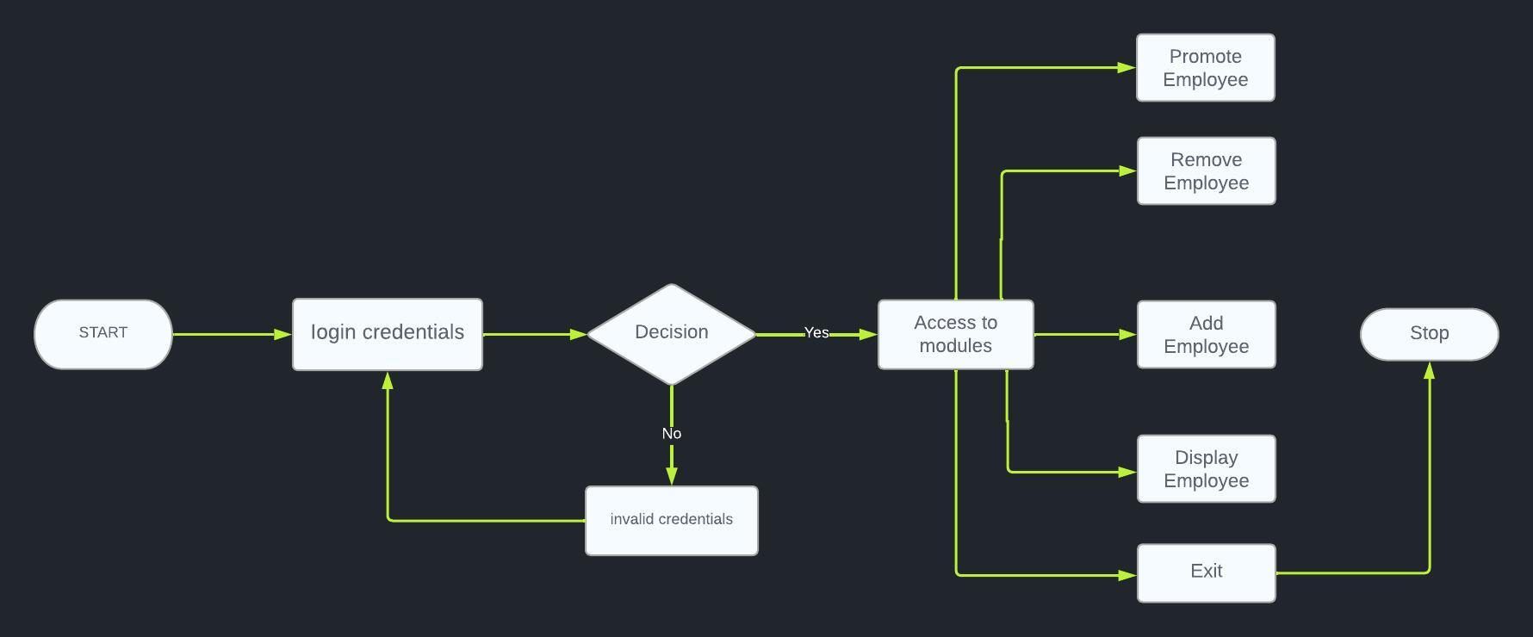

# CHAPTER 6

**IMPLEMENTATION**

**6.1 Main program**

# importing mysql connector

import mysql.connector

# making Connection

con = mysql.connector.connect(

host="localhost", user="root", password="2004", database="pragadeesh")

# Function to mAdd_Employee

def Add_Employ():

Id = input("Enter Employee Id : ")

# Checking if Employee with given Id

# Already Exist or Not

if (check_employee(Id) == True):

print("Employee already exists\nTry Again\n")

menu()

else:

Name = input("Enter Employee Name : ")

Post = input("Enter Employee Post : ")

Salary = input("Enter Employee Salary : ")

data = (Id, Name, Post, Salary)

# Inserting Employee details in

# the Employee Table

sql = 'insert into empd values(%s,%s,%s,%s)'

c = con.cursor()

# Executing the SQL Query

c.execute(sql, data)

# commit() method to make changes in

# the table

con.commit()

print("Employee Added Successfully ")

menu()

# Function to Promote Employee

def Promote_Employee():

Id = int(input("Enter Employ's Id"))

# Checking if Employee with given Id

# Exist or Not

if (check_employee(Id) == False):

print("Employee does not exists\nTry Again\n")

menu()

else:

Amount = int(input("Enter increase in Salary"))

# Query to Fetch Salary of Employee

# with given Id

sql = 'select salary from empd where id=%s'

data = (Id,)

c = con.cursor()

# Executing the SQL Query

c.execute(sql, data)

# Fetching Salary of Employee with given Id

r = c.fetchone()

t = r[0] + Amount

# Query to Update Salary of Employee with

# given Id

sql = 'update empd set salary=%s where id=%s'

d = (t, Id)

# Executing the SQL Query

c.execute(sql, d)

# commit() method to make changes in the table

con.commit()

print("Employee Promoted")

menu()

# Function to Remove Employee with given Id

def Remove_Employ():

Id = input("Enter Employee Id : ")

# Checking if Employee with given Id Exist

# or Not

if (check_employee(Id) == False):

print("Employee does not exists\nTry Again\n")

menu()

else:

# Query to Delete Employee from Table

sql = 'delete from empd where id=%s'

data = (Id,)

c = con.cursor()

# Executing the SQL Query

c.execute(sql, data)

# commit() method to make changes in

# the table

con.commit()

print("Employee Removed")

menu()

# Function To Check if Employee with

# given Id Exist or Not

def check_employee(employee_id):

# Query to select all Rows f

# rom employee Table

sql = 'select * from empd where id=%s'

# making cursor buffered to make

# rowcount method work properly

c = con.cursor(buffered=True)

data = (employee_id,)

# Executing the SQL Query

c.execute(sql, data)

# rowcount method to find

# number of rows with given values

r = c.rowcount

if r == 1:

return True

else:

return False

# Function to Display All Employees

# from Employee Table

def Display_Employees():

# query to select all rows from

# Employee Table

sql = 'select * from empd'

c = con.cursor()

# Executing the SQL Query

c.execute(sql)

# Fetching all details of all the

# Employees

r = c.fetchall()

for i in r:

print("Employee Id : ", i[0])

print("Employee Name : ", i[1])

print("Employee Post : ", i[2])

print("Employee Salary : ", i[3])

print("---------------------\

-----------------------------\

------------------------------\

---------------------")

menu()

# menu function to display menu

def menu():

print("Welcome to Employee Management Record")

print("Press ")

print("1 to Add Employee")

print("2 to Remove Employee ")

print("3 to Promote Employee")

print("4 to Display Employees")

print("5 to Exit")

ch = int(input("Enter your Choice "))

if ch == 1:

Add_Employ()

elif ch == 2:

Remove_Employ()

elif ch == 3:

Promote_Employee()

elif ch == 4:

Display_Employees()

elif ch == 5:

exit(0)

else:

print("Invalid Choice")

menu()

def acc():

while True:

choice = int(input("Enter 1 for creating account 2 for login: "))

if choice == 1:

def for_creating_account():

first_name = input("Give the First name: ")

last_name = input("Give the last name: ")

user_name = input("Give the user_name: ")

password = input("Give the passowrd: ")

data2 = (first_name ,last_name,user_name, password)

# Inserting details in

# the authentication Table

sql = 'insert into authentication values(%s,%s,%s,%s)'

c = con.cursor()

# Executing the SQL Query

c.execute(sql, data2)

# commit() method to make changes in

# the table

con.commit()

for_creating_account()

if choice == 2:

# Function to log in

def log_in():

user_name = input("Enter username: ")

password = input("Enter password: ")

sql = 'select * from authentication where user_name=%s and password=%s'

c = con.cursor()

data = (user_name, password)

# Executing the SQL Query

c.execute(sql, data)

# Fetching all details of the Employees

column = c.fetchall()

if len(column) > 0:

print("Login Successful")

menu()

else:

print("Invalid username or password")

# Rest of the code...

log_in()

acc()

# Calling menu functionl

# CHAPTER 7

**RESULT ANALYSIS**

**7.1 Result obtained**

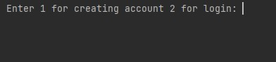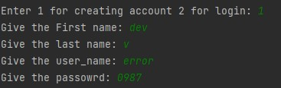

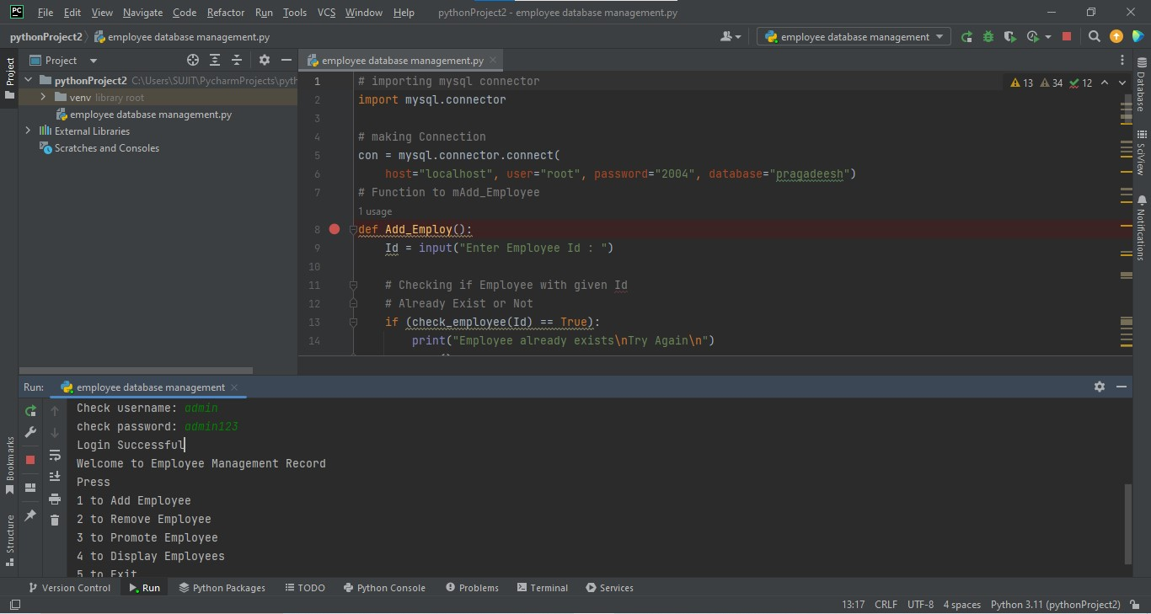

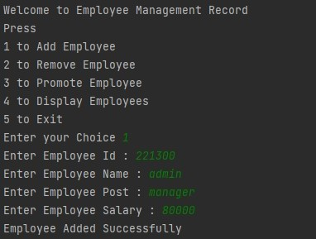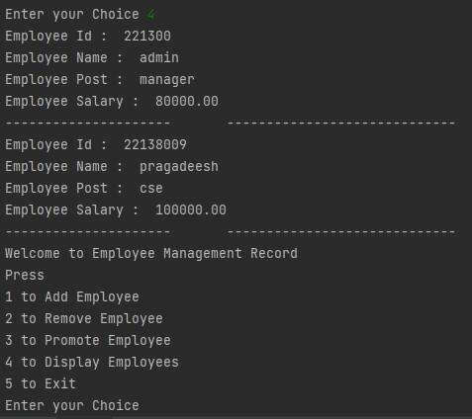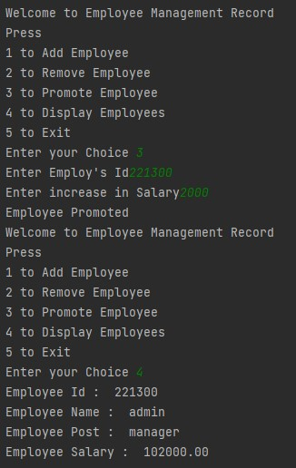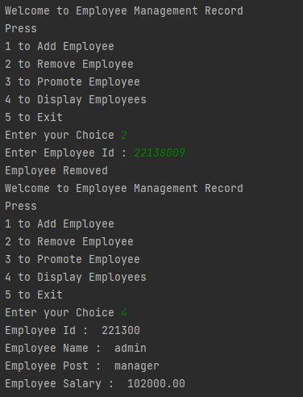

# CHAPTER 8

**CONCLUSION**

**8.1 conclusion**

The idea is that we perform different changes in our Employee Record by using different functions for example the Add_Employee will insert a new row in our Employee, also, we will create a Remove Employee Function which will delete the record of any particular existing employee in our Employee table.This System works on the concepts of taking the information from the database making required changes in the fetched data and applying the changes in the record which we will see in our Promote Employee System.We can also have the information about all the existing employees by using the Display Employee function.The main advantage of connecting our program to the database is that the information becomes lossless even after closing our program a number of times.IoT-based employee database management systems can contribute to energy efficiency initiatives within the organization.It's important to implement appropriate security measures when integrating IoT into employee database management systems to protect employee data and ensure compliance with privacy regulations.

# REFERENCES

# [1] – Begg Carolyn, Connolly Thomas, Database systems (a Practical approach to Design, Implementation, and Management), Addison-Wesley, an imprint of Pearson Education, University of Paisley (U.K.), Fourth edition 2005

# [2]-<http://msdn.microsoft.com/library/default.asp?url=/library/en-us/vbcon/html/vboritextboxctltasks.asp> (2006-05-25).

# [3] – Dawen Ding, Zhiqiang Zhao, The Design of University Staff Data Management System Based on MBSE, 10.1109/ICIEA48937.2020.9248413, 09 November 2020

# [4] – Joydip Sarmah, Nelson R Varte, Sanjay Jyoti Dutta , Human Resource Management System: A case study on an Information Management Design,December 2018,DOI:[10.1109/ICINPRO43533.2018.9096835](http://dx.doi.org/10.1109/ICINPRO43533.2018.9096835)

# [5]-Bodnar George /Duquesne University/, Hopwood William /Florida Atlantic University/, Accounting Information systems, Eighth Edition, Prentice Hall, Upper Saddle River, New Jersey .

# 